This is simple project using Springboot Application to display Employee details

**Tools Used**

1. Eclipse: An IDE to code for the application
2. Java: A programming language to develop the prototype
3. Maven: A build tool for adding all the external dependencies
4. Git: To connect and push files from the local system to GitHub
5. GitHub: To store the application code and track its versions
6. Jenkins: To build CI/CD pipelines
7. Docker: To deploy jar in a container to access it from EC2
8. AWS: To deploy the application

**Data Structures & Techniques Used**

1. Spring Boot : Popular Java Framework to acheive inversion of control and dependency injection
2. Spring MVC : Model View Controller by Spring

**Application Flow Chart**

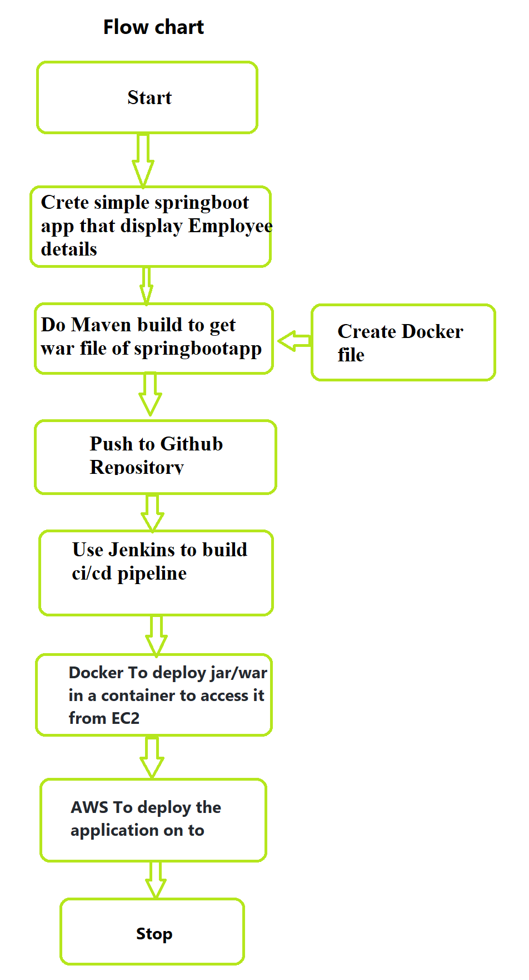

**Step by Step Build Process**

**1. Create a Java Project**

Create a simple Spring project using Eclipse and Maven and push it to GitHub

**Sample Output**

**2. Configure Jenkins**

Create a new task and use Git repository as source code management

**Home page Results from Spring boot application**

**Home page**

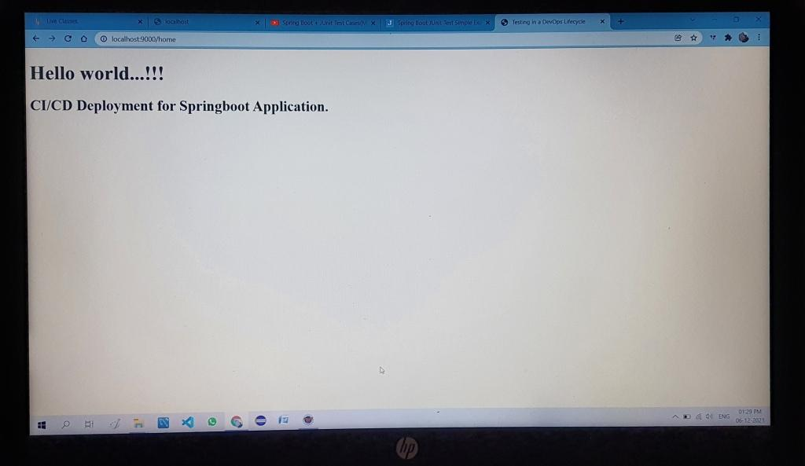

**Employee page**

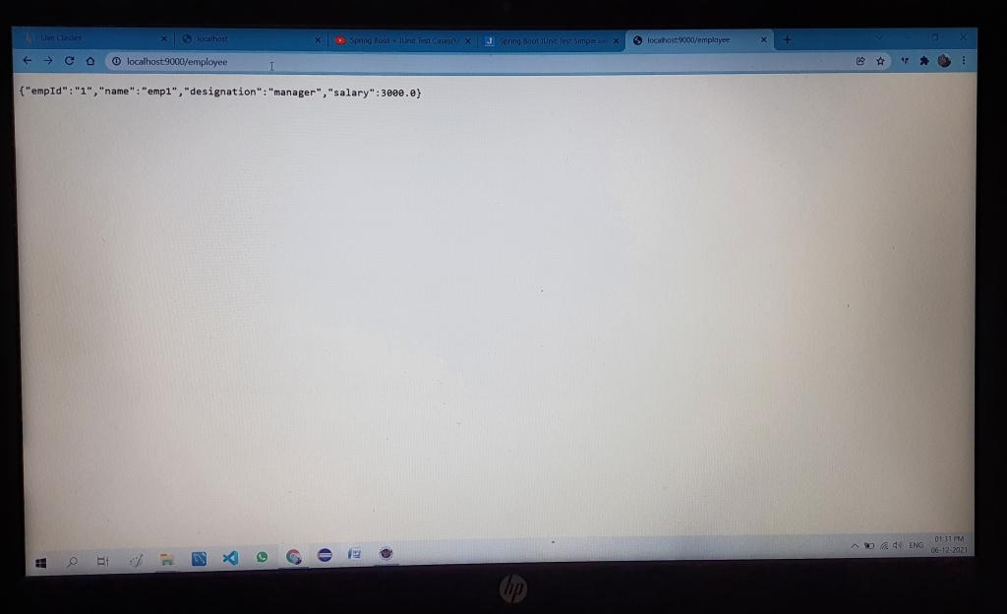

**Junit testing**

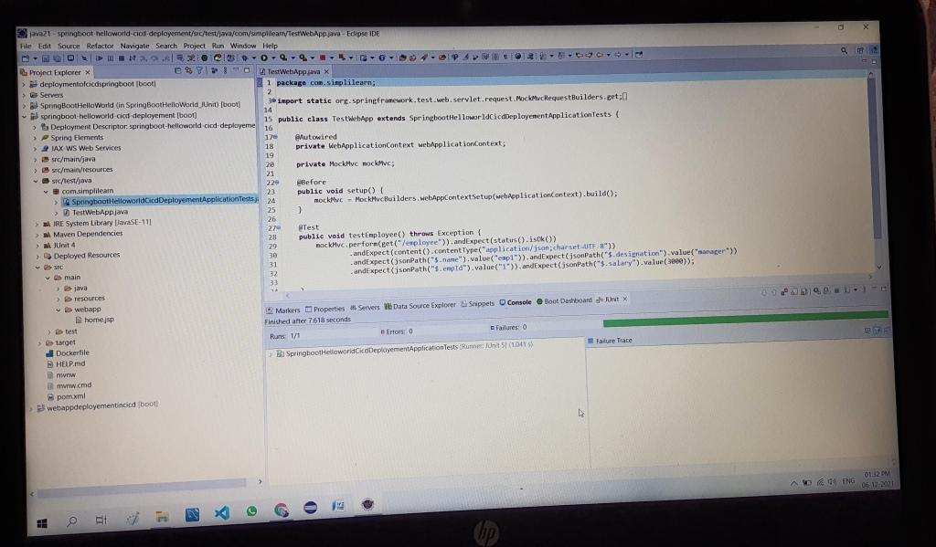

**Git Hub Repository**

Push the spring boot app to github

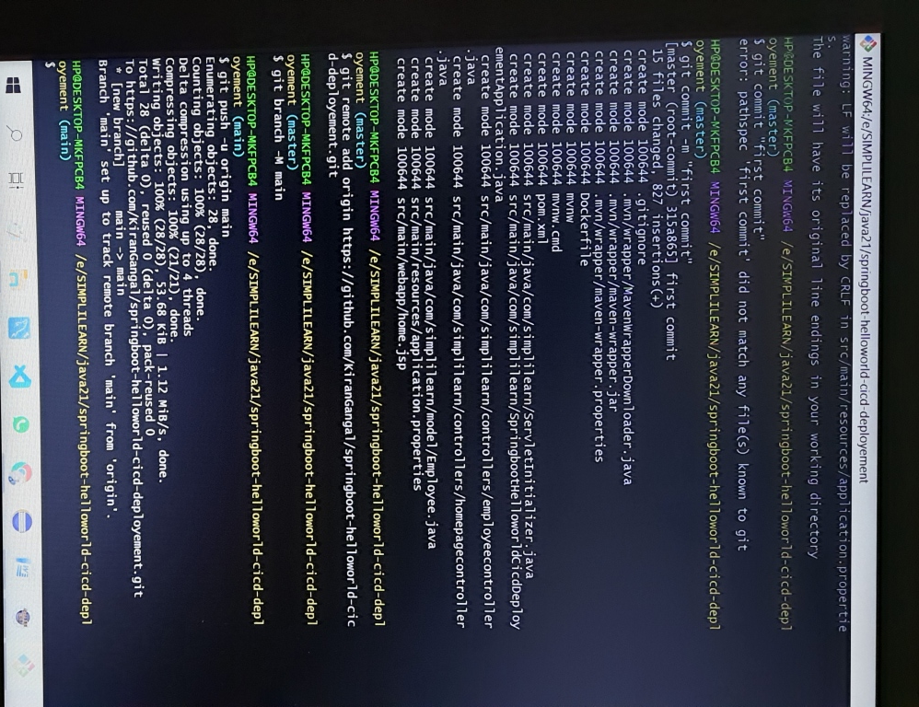

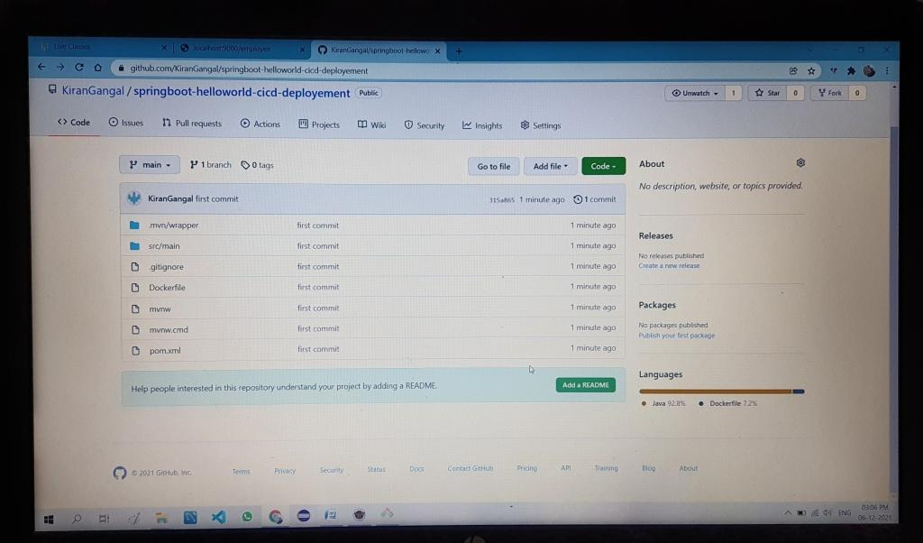

**Jenkins**

**Jenkin settings**

Select Poll SCM option in order to let jenkins start a new build whenever there is a change in git repository

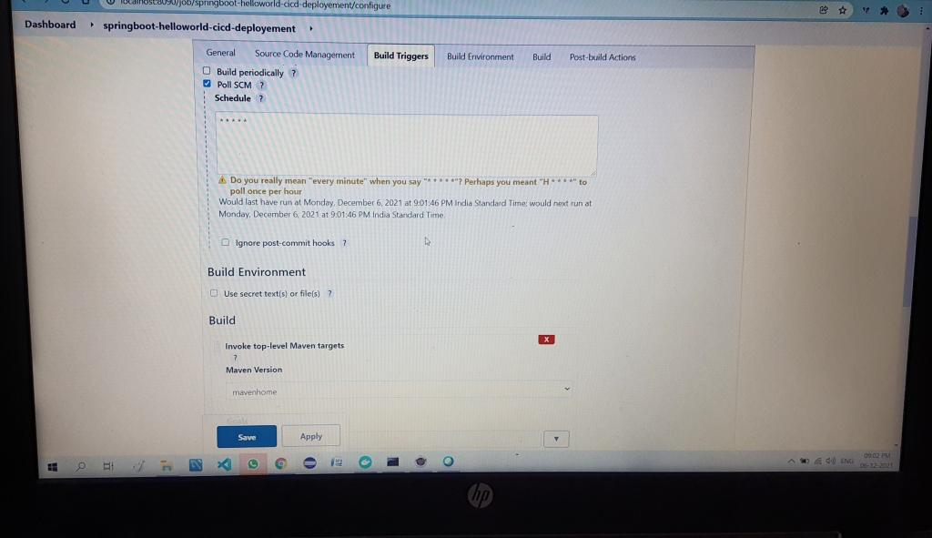

**Jenkins Build Application**

After all the configuration is done, click build now and wait the magic

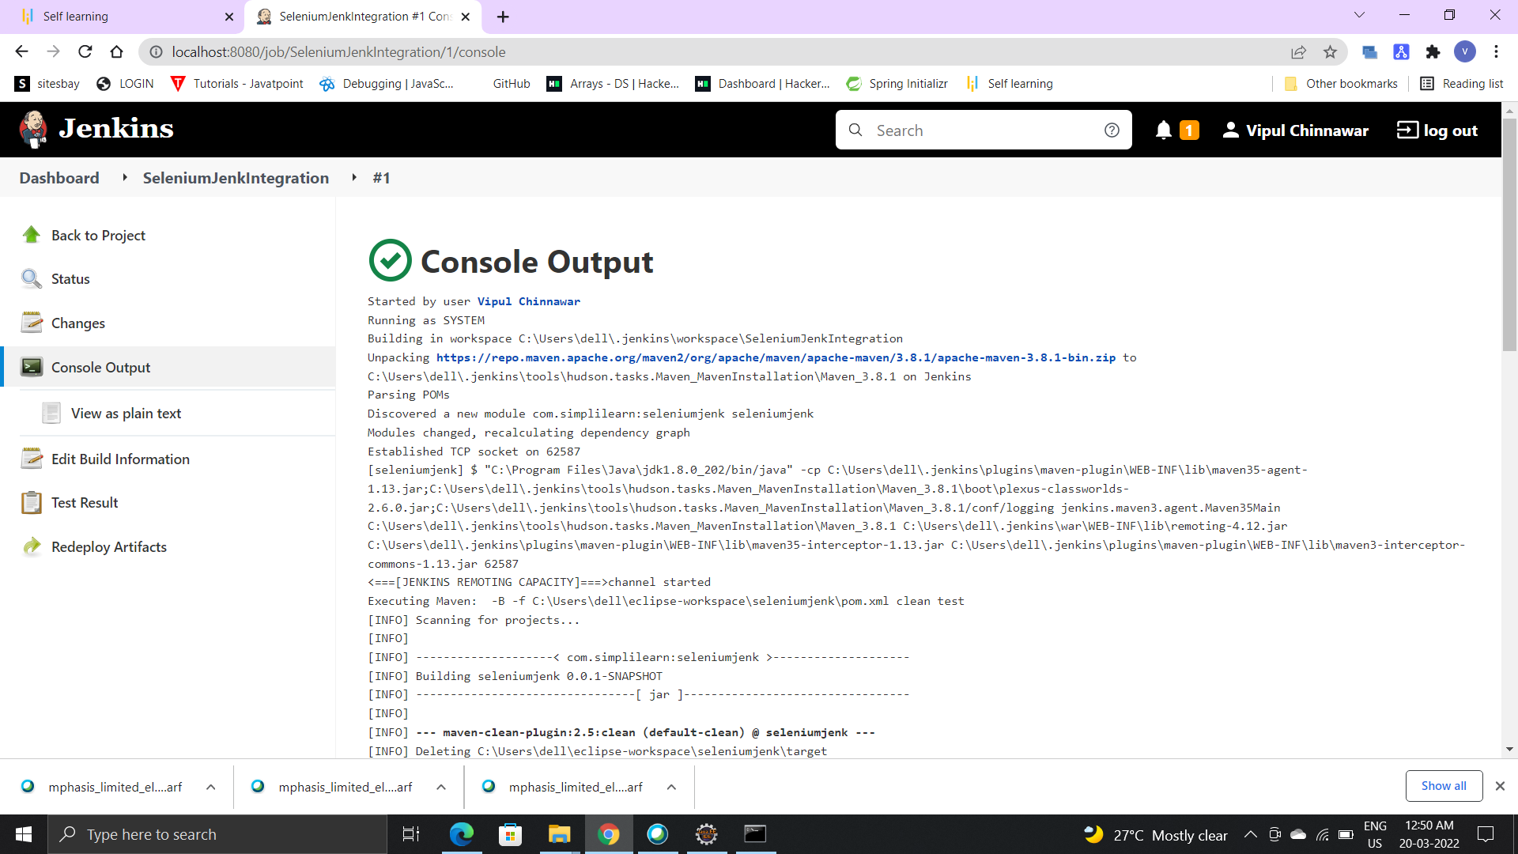

**Deploy Application in Amazon EC2**

* Create a linux EC2 instance and launch it
* Then pull the docker image from docker hub using command 'docker pull userid/imageid'

**Amazon EC2 Configurations**

Go to AWS website

Step1

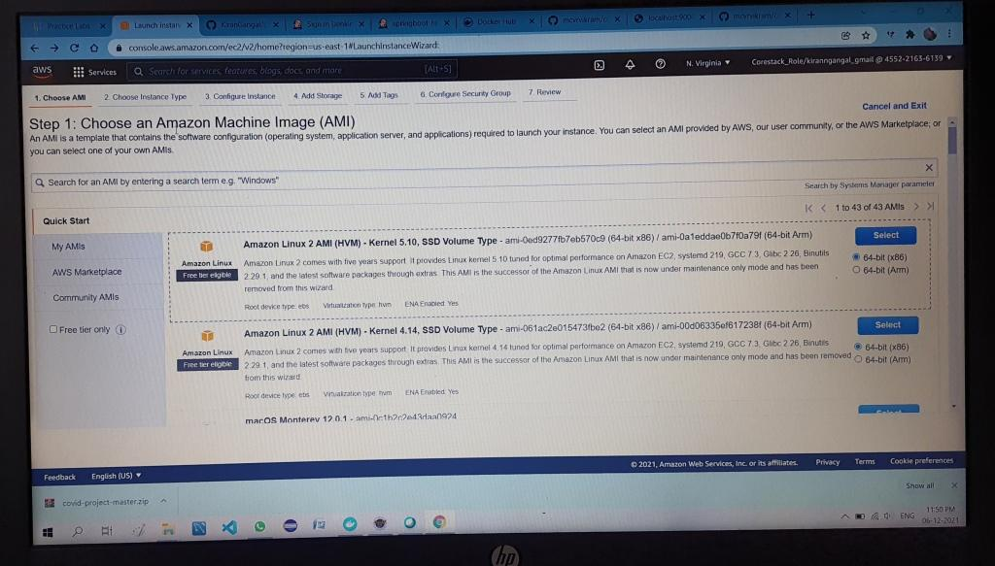

Step2

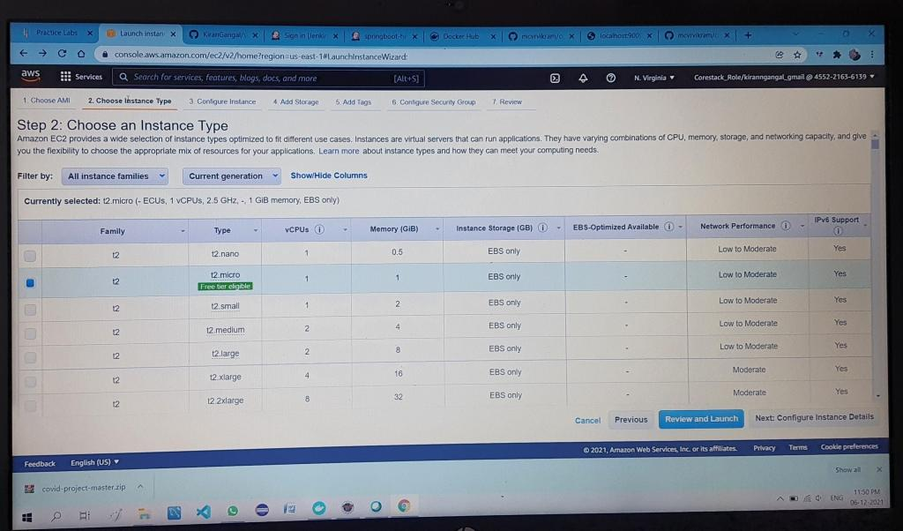

Step 3

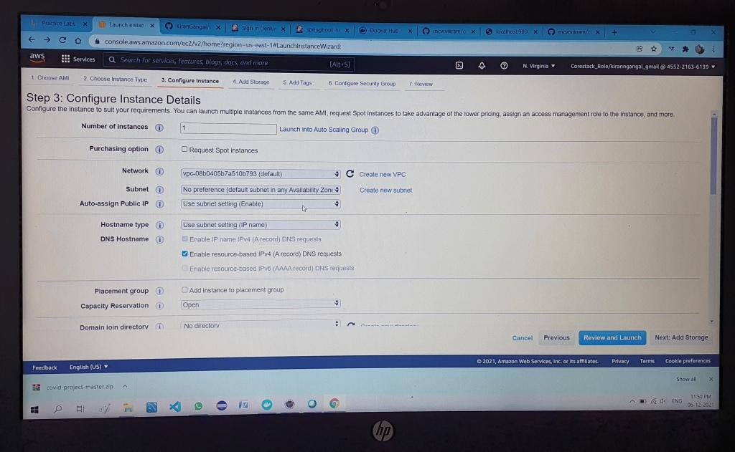

Step 4

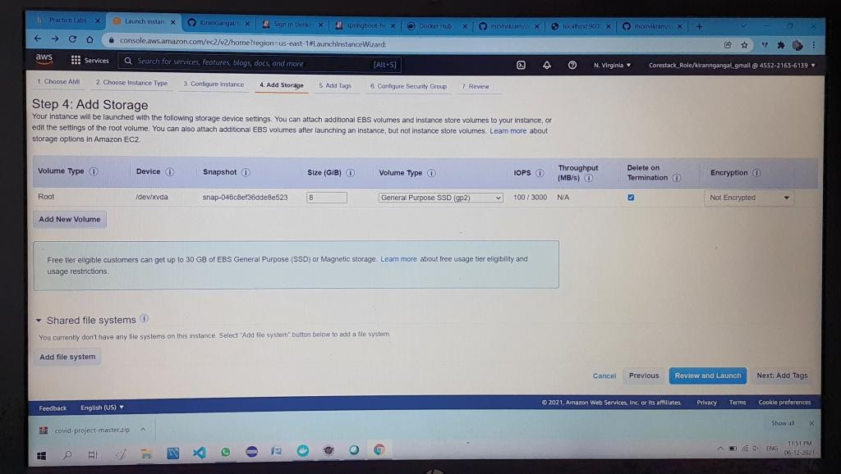

Step 5

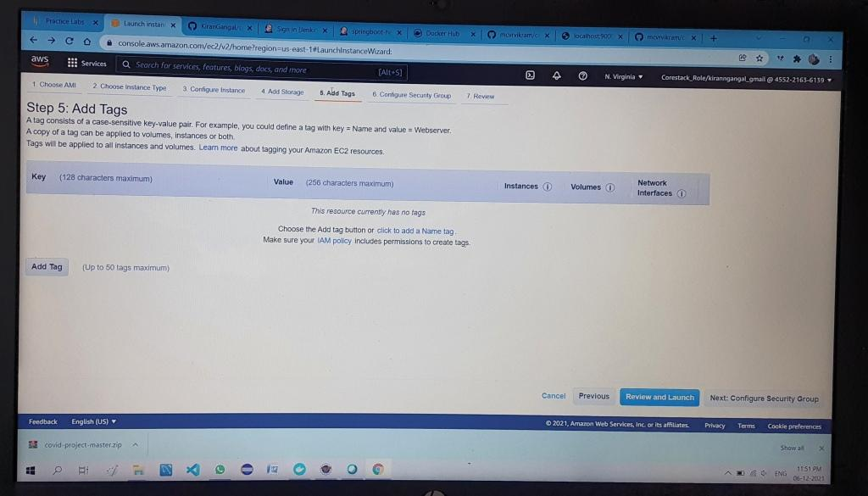

Step 6

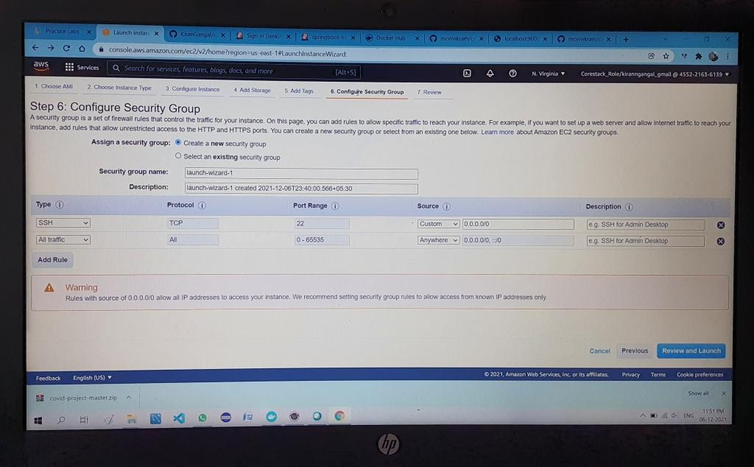

Step 7

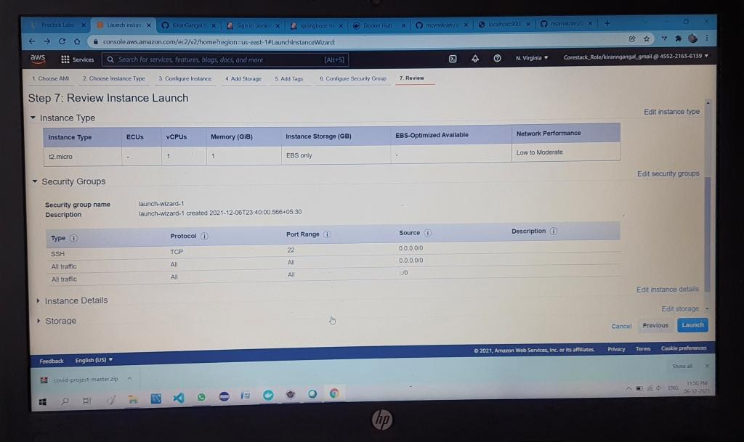

Step 8

Run the docker image using command 'docker run -p portnumber:portnumber imageid

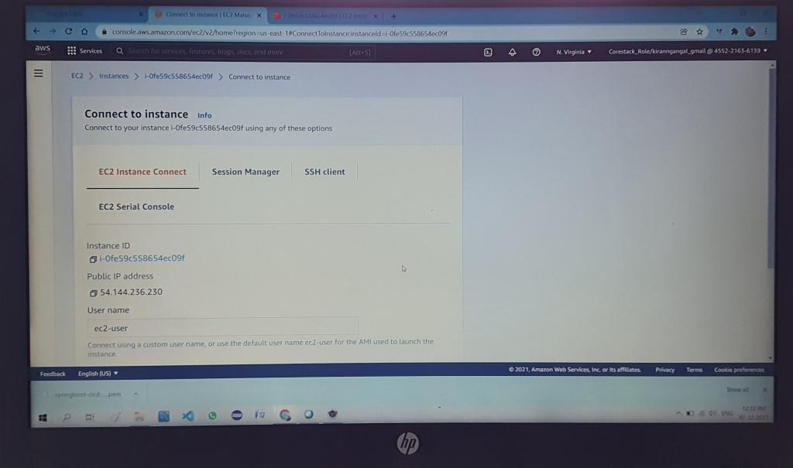

**Run Jar in AWS EC2**

* Once our application is launched in linux EC2 instance, we can go to our EC2 instance and copy the public IP
* Launch our application using the URL publicIP:portnumber and That's it!

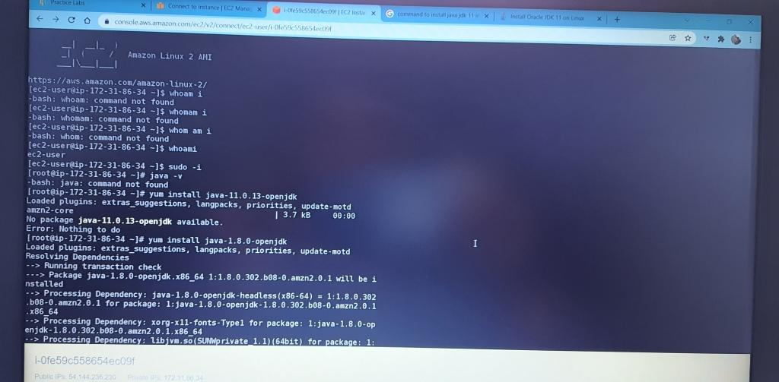

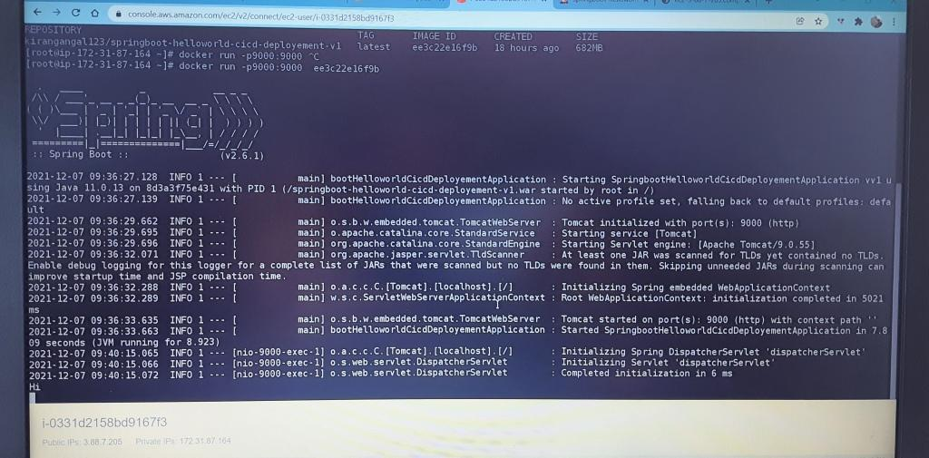

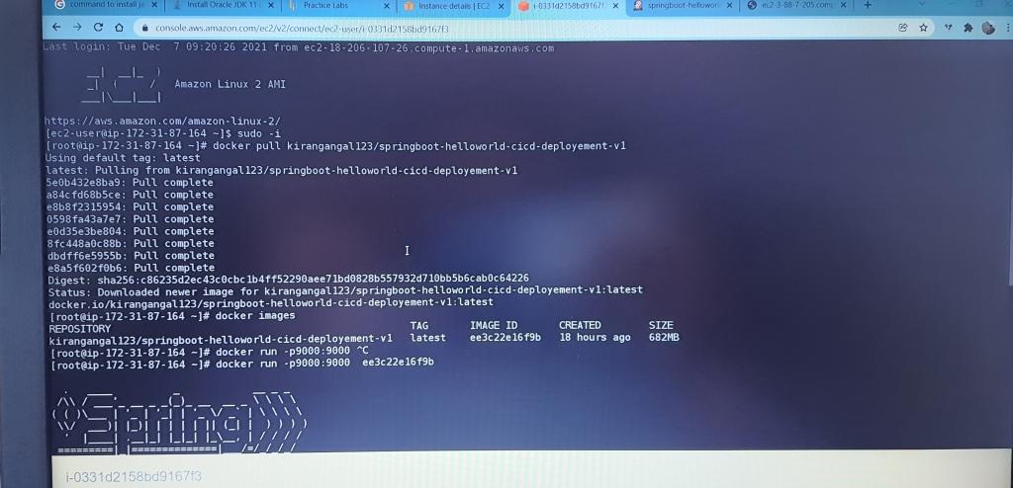

**Final Output**



